MEHRAN UNIVERSITY

OF ENGINEERING & TECHNOLOGY

JAMSHORO, PAKISTAN

Learn to compute network address, network broadcast address, number of subnets and hosts for different IP classes

Subject: COMPUTER NETWORKS (Pr)

(Lab 1 - Tasks Solution)

|  |  |
| --- | --- |
| **Roll No:** | **22SW028** |
| **Section:** | **I** |

**Task#01**

**Use the following information and the previous examples to answer the following subnet-related questions A company has applied for and received a Class C network address of 197.15.22.0. The physical network is to be divided into 4 subnets, which will be interconnected by routers. At least 25 hosts will be needed per subnet. A Class C custom subnet mask needs to be used and a router is needed between the subnets to route packets from one subnet to another. Determine the number of bits that need to be borrowed from the host portion of the network address and the number of bits that will be left for host addresses.**

Solution:

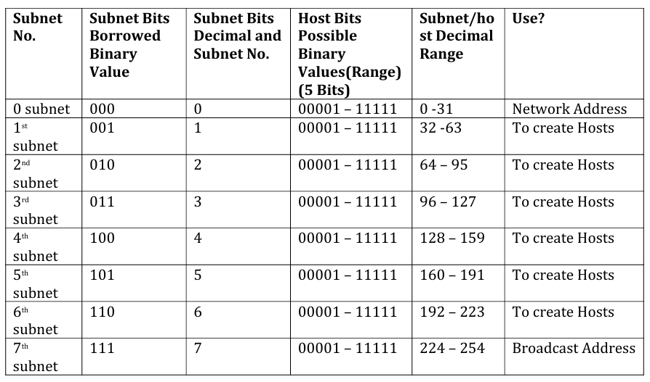

**ANSWER TO THE QUESTIONS:**

**1. Which octet(s) represent the network portion of a Class C IP address?**

**Ans:** In a Class C address, the first three octets represent the network portion.

**2. Which octet(s) represent the host portion of a Class C IP address?**

**Ans:** The fourth octet represents the host portion.

**3. What is the binary equivalent of the Class C network address in the scenario?**

**Ans:** 197.15.22.0 **=>** 11000101.00001111.00010110 0.00000000

**4. How many high-order bits were borrowed from the host bits in the fourth octet?**

**Ans:** We need 4 subnets, which requires 2 bits (since 22 = 4), hence 2 bits were borrowed

**5. What subnet mask must be used? Show the subnet mask in decimal and binary.**

**Ans:** Starting from the default Class C subnet mask (255.255.255.0), borrowing 2 bits for the subnet gives:

Binary: 11111111.11111111.11111111.11000000

Decimal: 255.255.255.192

The subnet mask is 255.255.255.192/26.

**6. What is the maximum number of subnets that can be created with this subnet mask?**

**Ans:** 4 Subnets

**7. What is the maximum number of usable subnets that can be created with this mask?**

**Ans:** 4 Usable Subnets

**8. How many bits were left in the fourth octet for host IDs?**

**Ans:** Since 2 bits are borrowed from the 8 host bits, 8−2=68 - 2 = 68−2=6 bits are left for host IDs.

**9. How many hosts can be defined with this subnet mask?**

**Ans:** With 6 bits available for hosts, 26 − 2= 64 – 2 = 62

62 hosts can be defined per subnet.

**10. What is the maximum number of hosts that can be defined for all subnets with this scenario?**

**Ans:** With 4 subnets and 62 hosts per subnet, the total is 4×62=248 hosts.

**11. Is 197.15.22.63 a valid host IP address with this scenario?**

**Ans:** The subnet ranges with mask /26 (255.255.255.192) are:

197.15.22.0 - 197.15.22.63 (subnet 1)

197.15.22.64 - 197.15.22.127 (subnet 2)

197.15.22.128 - 197.15.22.191 (subnet 3)

197.15.22.192 - 197.15.22.255 (subnet 4)

197.15.22.63 is the broadcast address for the first subnet and cannot be assigned to a host. So No, it is not a valid host IP address

**12. Why or why not?**

**Ans:** 197.15.22.63 is the broadcast address for the first subnet, so it cannot be assigned to a host.

**13. Is 197.15.22.160 a valid host IP address with this scenario?**

**Ans:** Yes, it’s a valid host address.

**14. Why or why not?**

**Ans:** 197.15.22.160 is within the usable range of the third subnet, so it can be assigned to a host.